**Assignment No: - 2**

**Facial Recognition using OpenCV**

**Problem Statement:**

Facial Recognition Using OpenCV and Deep Learning for Binary Classification.

**Objectives:**

1. To implement facial recognition using OpenCV and deep learning techniques for binary classification (e.g., recognizing if a person is authorized or unauthorized).
2. To understand how facial recognition systems work by detecting, extracting, and classifying facial features.
3. To explore how deep learning models can be applied for accurate facial recognition in real-world applications.

**Theory:**

Facial recognition is a biometric technology that uses facial features to identify or verify a person’s identity. The process involves detecting a face in an image or video, extracting unique features (such as the distance between the eyes or the shape of the jaw), and comparing these features to known faces stored in a database. Modern facial recognition systems often employ deep learning models for more accurate detection and recognition.

OpenCV (Open Source Computer Vision Library) provides pre-trained models for face detection, and when combined with deep learning, it can be used for robust facial recognition. In this project, binary classification refers to identifying if the person is a known or authorized individual (1) or an unknown/unrecognized individual (0).

**Methodology:**

1. **Data Collection**: Gather images of authorized persons and label them as positive samples. Collect images of other individuals for negative samples.
2. **Preprocessing**:
   * Convert images to grayscale.
   * Normalize the pixel values.
   * Resize images for consistency.
3. **Face Detection**:
   * Use OpenCV’s Haar cascades or deep learning-based models (e.g., DNN module in OpenCV) to detect faces in images.
4. **Feature Extraction**:
   * Extract facial features using deep learning models such as Convolutional Neural Networks (CNNs).
5. **Binary Classification**:
   * Train a deep learning model (e.g., a CNN) to classify whether the detected face is recognized or not.
6. **Model Training**:
   * Use a dataset of labeled images to train the model for binary classification (0: unauthorized, 1: authorized).
7. **Evaluation**:
   * Test the model on new images and measure its accuracy, precision, recall, and F1 score.

**Working Principle / Algorithm:**

1. **Face Detection**:
   * Input: Capture an image or video frame.
   * Detect the face using OpenCV's face detection algorithms (e.g., Haar cascades or DNN-based detection).
2. **Face Alignment and Preprocessing**:
   * Align the face and normalize the input (resize, grayscale, etc.).
3. **Feature Extraction**:
   * Apply a deep learning model to extract facial features.
   * Use a pre-trained CNN or design a custom CNN to capture the unique features of the face.
4. **Classification**:
   * Feed the extracted features into a binary classification model.
   * Output: The model predicts whether the face is recognized (authorized) or not (unauthorized).
5. **Matching**:
   * Compare the detected face with stored faces in the database to verify the person’s identity.
6. **Result**: Output whether the face is recognized or not based on the binary classification result.

**Advantages:**

1. **High Accuracy**: Using deep learning models improves the accuracy of facial recognition systems, especially when dealing with large datasets.
2. **Automation**: Facial recognition can automate security processes (e.g., unlocking devices, granting access to buildings).
3. **Non-Intrusive**: Unlike fingerprint or iris recognition, facial recognition works from a distance, making it a more user-friendly biometric solution.
4. **Fast Detection**: With optimized algorithms, face detection and recognition can be performed in real-time.

**Disadvantages / Limitations:**

1. **Privacy Concerns**: The use of facial recognition raises ethical concerns regarding surveillance and privacy.
2. **Dependence on Lighting and Angles**: The performance of the system can degrade with poor lighting or varying angles of the face.
3. **False Positives/Negatives**: The system might incorrectly classify a person as authorized or unauthorized, leading to security risks.
4. **Bias**: Some facial recognition models may exhibit bias towards certain demographic groups, leading to inaccurate results for those populations.

**Diagram:**

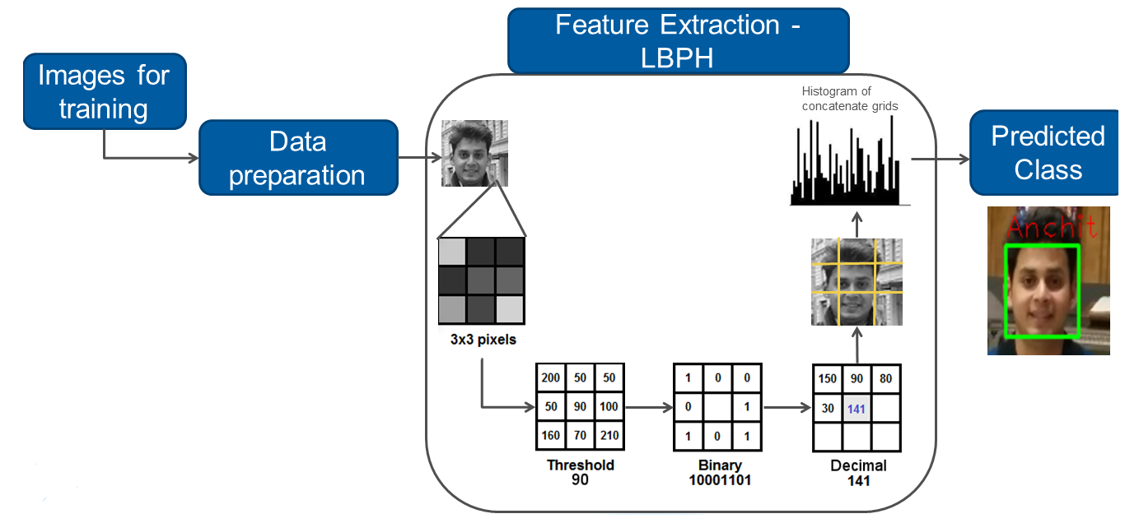

**Conclusion:**

The OpenCV-based facial recognition system is a powerful and efficient tool for recognizing faces in real-time. Leveraging classical computer vision techniques such as Haar Cascades or deep learning-based models, OpenCV can effectively detect and recognize facial patterns. Its strength lies in its speed and versatility, making it suitable for various applications like surveillance, access control, and user authentication. However, challenges like varying lighting conditions, occlusions, and the need for pre-trained models to achieve high accuracy must be considered. With proper optimization, OpenCV can provide reliable and scalable facial recognition solutions across different industries.